Name:_________________________________________________ Pd:______________ Date:________
Quiz – Projectile Motion – Multiple Choice (10 pt)
Use the diagram below to help you answer questions 1 – 5. It represents a ball throw from a rooftop with a velocity (v) at an angle (θ) and landing on the ground (ignore air resistance). A, B, C, & D represent positions of the ball while it is a projectile (after release and before impact).
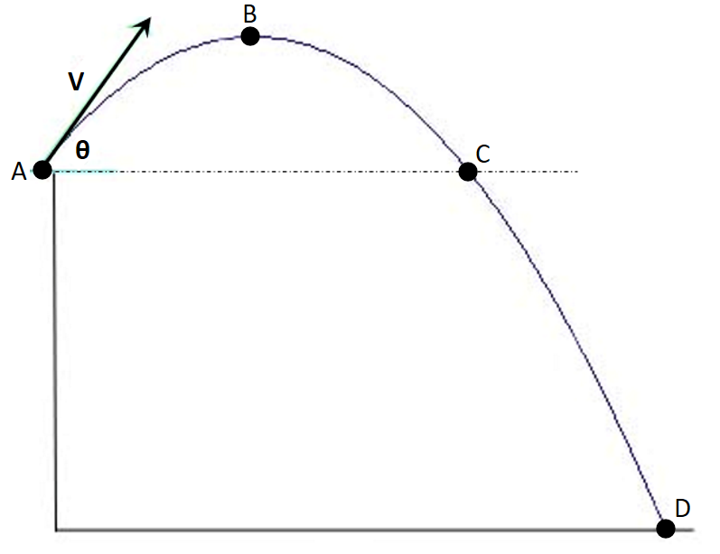

______ 1. Which of the following vectors best represents the ball’s velocity at point B?

a) b) c) d)

______ 2. Which of the following vectors best represents the ball’s acceleration at point C?

a) b) c) d)

______ 3. What is the initial velocity in the horizontal direction?

a) 0 m/s b) $v∙sinϴ$ c) $v∙cosϴ$ d) 9.8 m/s

______ 4. Where is the ball moving the fastest?

a) Point A b) Point B c) Point C d) Point D

______ 5. Which of the following statements is TRUE?

a) The time to Point B is exactly half of the time to Point D.
b) The ball’s speed at Point C is the same as the speed at Point A.
c) The ball will strike the ground at the same angle it was launched.
d) The velocity at Point B is 0 m/s.

______ 6. While riding at a constant speed on a train at Kiddle Park, Victor Velocity playfully tossed Fluffy straight upward. During the time Fluffy was in the air, the train moved forward one meter. Assuming no air resistance, Fluffy landed…
a) in Victor’s loving arms
b) one meter in front of Victor
c) one meter behind Victor
d) several meters behind Victor

______ 7. A bullet is fired horizontally from a gun. At the same time, an identical bullet is dropped from the same height. Assuming no air resistance and level ground, the fired bullet should:
a) hit the ground first
b) hit the ground second
c) hit the ground at the same time as the dropped bullet
d) never hit the ground

______ 8. When a ball is kicked at an angle to the horizontal, what component of the ball’s initial velocity determines the amount of time the ball will spend in the air?
a) the horizontal component
b) the vertical component
c) both the horizontal and vertical components factor into the time of flight
d) none of these

______ 9. Which of the following statements is true when an object is launched at angles of 15° and 75° to the horizontal on level ground with no air resistance?
a) The time of flight is the same.
b) The maximum height the ball will reach is the same.
c) The horizontal velocities are the same.
d) The horizontal distance traveled is the same.

______ 10. A ball is kicked from the ground on a level surface. The horizontal distance the ball travels in the air will be maximized when kicked at what angle ϴ?

a) 0° b) 30° c) 45° d) 60° e) Other

